[INSERT COMPANY LOGO]
FOR IMMEDIATE RELEASE

CONTACT:
[Name]
[Email]
[Phone]

[Company Name] Inspires Students to Envision a Sustainable Future Through Spring Scholarship Program
[CITY, State, Release Date] – This spring, [Company Name] is inspiring students to create a more sustainable future while funding a scholarship program to bring much-needed school supplies into the classroom. Part of the national initiative, TICCIT (short for Trees Into Cartons, Cartons Into Trees), the 2021 scholarship program aims to teach first-through-fifth grade students about the importance of trees, recycling, and the environment. Adopted for the virtual world, this year’s programming will feature video lessons and allow students to submit their own creative projects into the scholarship contest.

To take part, teachers and administrators can register their school or youth organization at: www.paperbox.org/ticcit-scholarship-program. Once registered, organizations will receive a TICCIT video that showcases the importance of trees, the paper-making process, and how recycling works. After learning about sustainability, students can submit their wishes for a more sustainable future in the form of artwork, photos, videos, poetry, letters, or any other creative virtual medium. With parental consent, each submission will enter into the scholarship contest, which will award school supplies to the students’ organizations or classrooms.

“[COMPANY NAME] is thrilled to support this year’s virtual TICCIT program and teach young people about the importance of sustainability and recycling,” said [Executive’s Name, Title, of Company Name]. “We know that importance firsthand—we create sustainable, recyclable paper packaging every day! Now it’s time to spread the word and help the next generation take part in our shared sustainable future.” [Please feel free to adjust/change the quote based on why TICCIT is important to your company.]

Created in 2010 by the Paperboard Packaging Council (PPC), a trade association for companies that make paperboard packaging, the TICCIT program is normally held in person at schools across the country around Earth Day. After classroom learning sessions, students pot tree saplings into paperboard cartons filled with soil to take home and plant with their families. The paper cartons will naturally biodegrade once planted, completing the “trees into cartons, cartons into trees” lifecycle. In-person TICCIT events will likely resume in 2022 or when deemed safe.
For this year’s virtual program, students are asked to submit their sustainability wishes by May 14, 2021. Visit http://www.paperbox.org/earthday for information on TICCIT, the scholarship contest, and how to get started.

PHOTO CAPTION: [Company Name] is inspiring students to create a more sustainable future with TICCIT this spring.
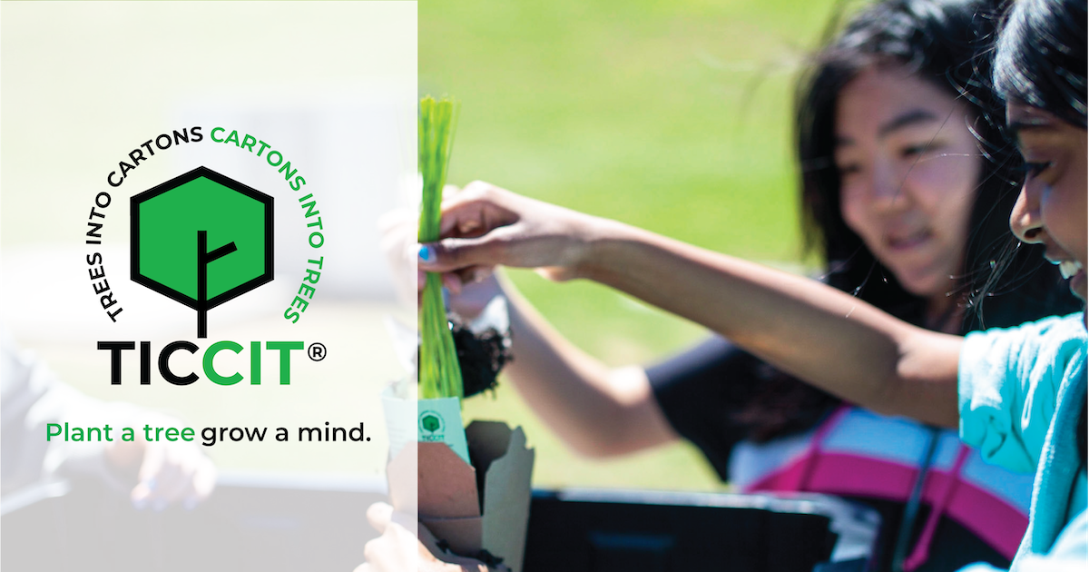

About [Company Name]
INSERT BOILERPLATE TEXT
About the Paperboard Packaging Council
Now in its 92nd year, the Paperboard Packaging Council (PPC) is the North American association for converters of paperboard packaging and their suppliers. PPC works to grow, promote and protect the paperboard packaging industry while providing its members with resources and tools to compete successfully in the marketplace. For more information, visit www.paperbox.org.

###

