Resources for mask making;

HEPPA filter vacuum bags (to cut for inner layer in mask)

https://www.bedbathandbeyond.com/store/product/royal-aire-dirt-devil-reg-7-pack-type-r-bags/1018109492?keyword=heppa-filter-vacuum-cleaner-bags

You will need elastic, or ties: elastic is easier! To loop around ears. The round elastic is best.
Depending on how many masks you are making, the yardage is inexpensive.

Etsy is a great resource for sewing materials. Be sure to check where things are being shipped from since if they come from overseas this can take weeks! (Amazon has sewing notions too!)

You can get beautiful fabrics on Etsy inexpensively, and in small quantities. The outer layers of masks are generally made with colorful cotton. The inner layer is generally a layer of Heppa filter and a layer of Tshirt material (good ol’ cotton jersey). While this will not filter the tiny Covid 19 particulate, it may have a percentage of effectiveness (there are only two studies that rate these to date, but they show some percentage of effectiveness: better than nothing.

Here are some websites for mask making:

https://www.sewcanshe.com/blog/5-free-diy-face-mask-tutorials-using-fabric

Some have downloadable patterns like this one:

https://www.craftpassion.com/face-mask-sewing-pattern/#face-mask-pattern

There is a pattern further below that was developed locally to cover N95 masks: this goes almost up to the eyes, covers mouth, sides of face and chin. See next page;

If you can slide it into i-photos, and choose a full page printing option it should be about the right size: measure the bar at the bottom of the page to assess 6” accuracy.

So that’s masks;
Now, if you want to make face shields, these are very simple and materials are available online.

You will need:
1 clear plastic shower curtain liner (this will make as many as thirty! But may be the smallest available.

12x 12 piece of a paper bag, measure out in 3 inch squares as shown in the pattern further on

Lightweight polypropylene webbing (1 inch wide, available for various yardages on Amazon)
One fifty inch piece of 1 inch wide lightweight polypropylene “ribbon” per mask; sew a quarter inch down from the top of the plastic shield material, centered so the ends for tying are even. Sew each edge of the band of polypropylene to the plastic shield.

This is worn tied above the brow to drape over eyes, nose mouth and chine:
This adds to the effectiveness of the face mask.
This is useful if someone in your life space becomes infected to add protection from droplets.

Here are some patterns:

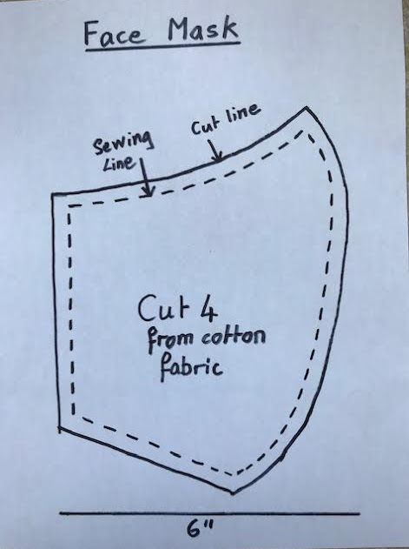This mask is designed to cover an N95 mask if available.

Otherwise this will need the full Heppa filter/T shirt layering.

Each of these takes some time to create.

Elastic or ties can be attached at the seams of the shorter side of the pattern.
